/\* Ashok

Variables and Expressions Lab

6.18.19 \*/

1… we already have Data flow Task from last lab so we will work on that

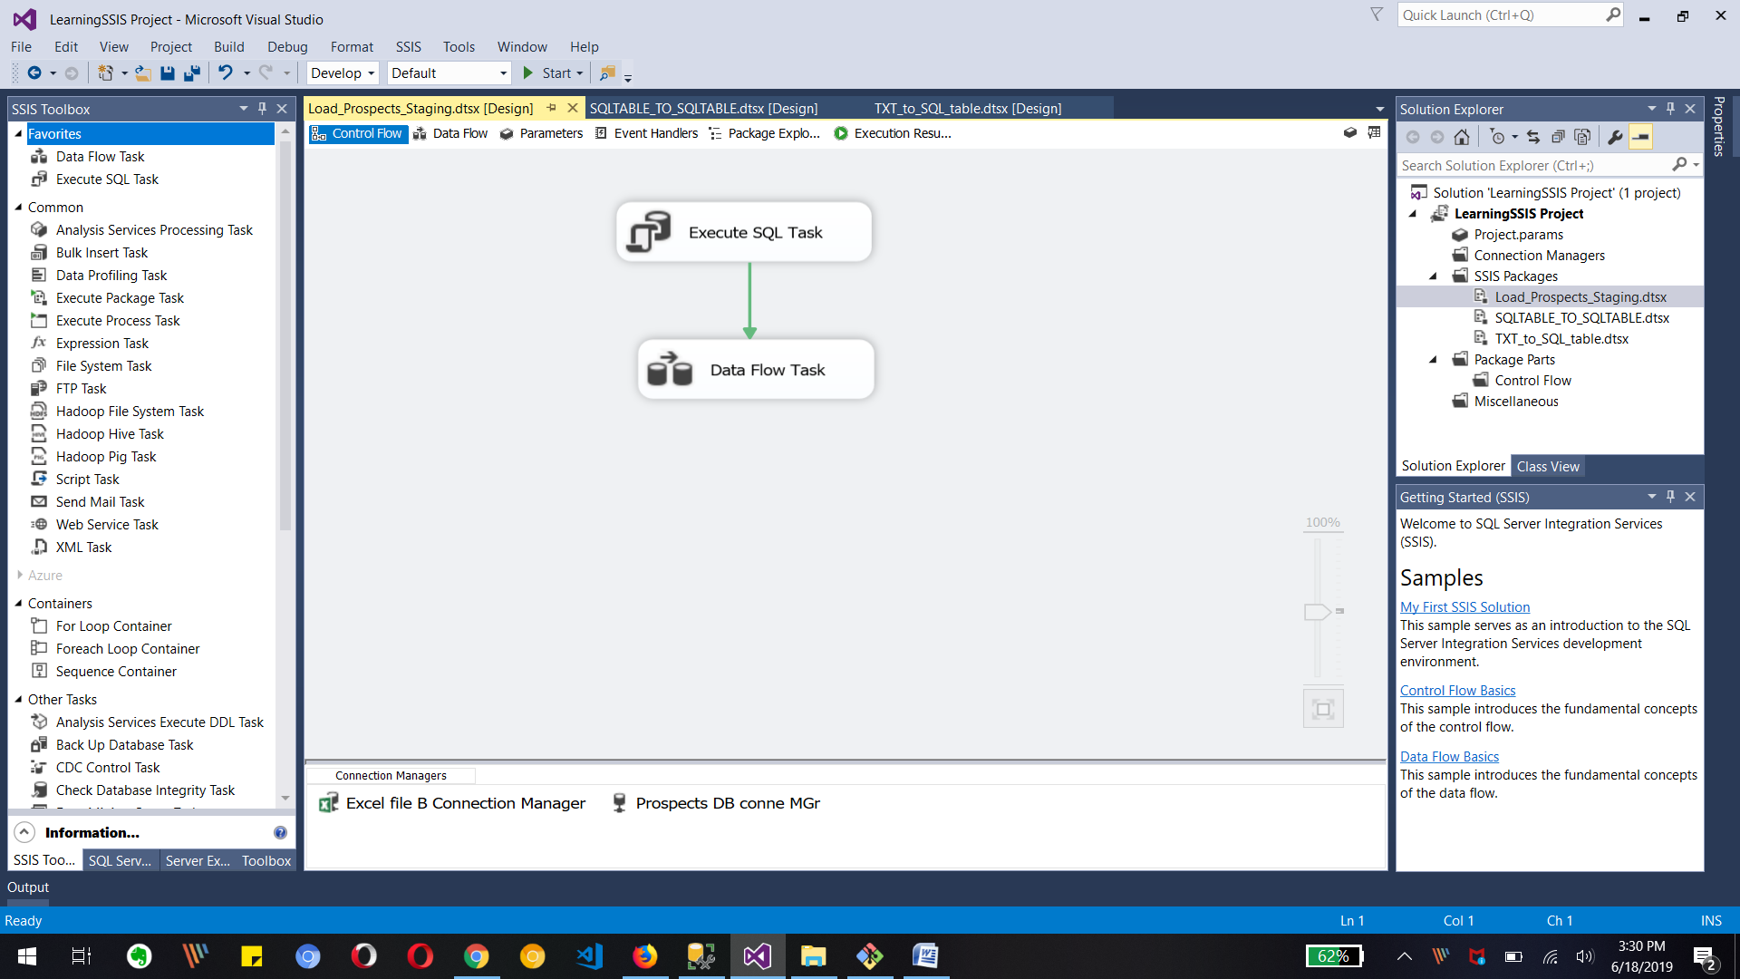

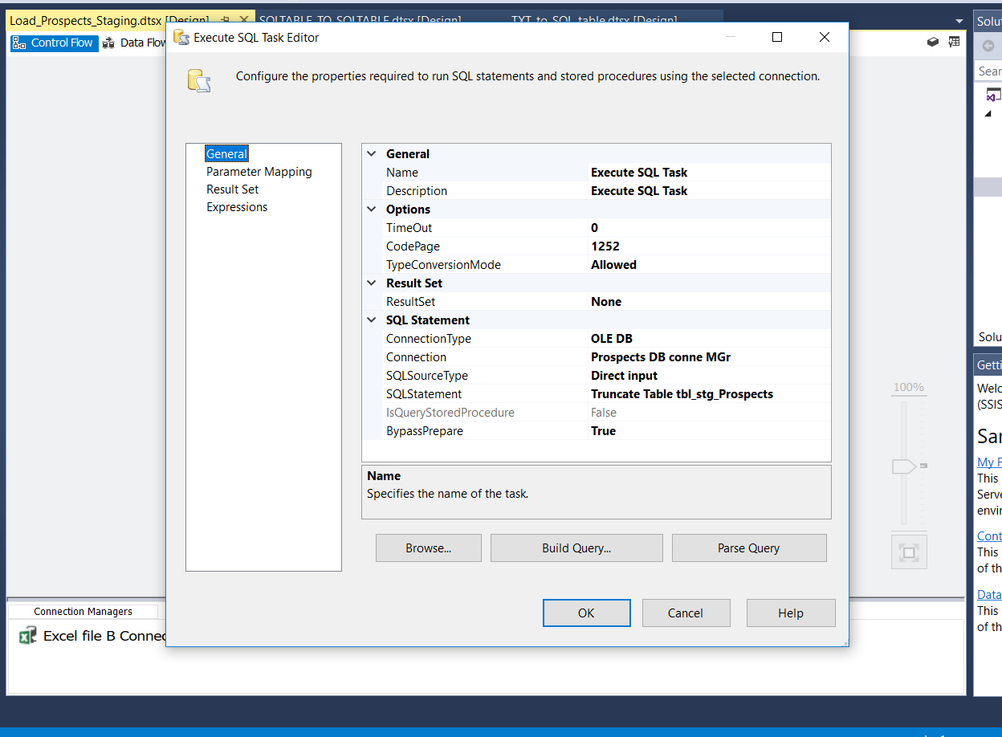

Adding Execute SQL task to truncate the Table and write sql statement in its editor.

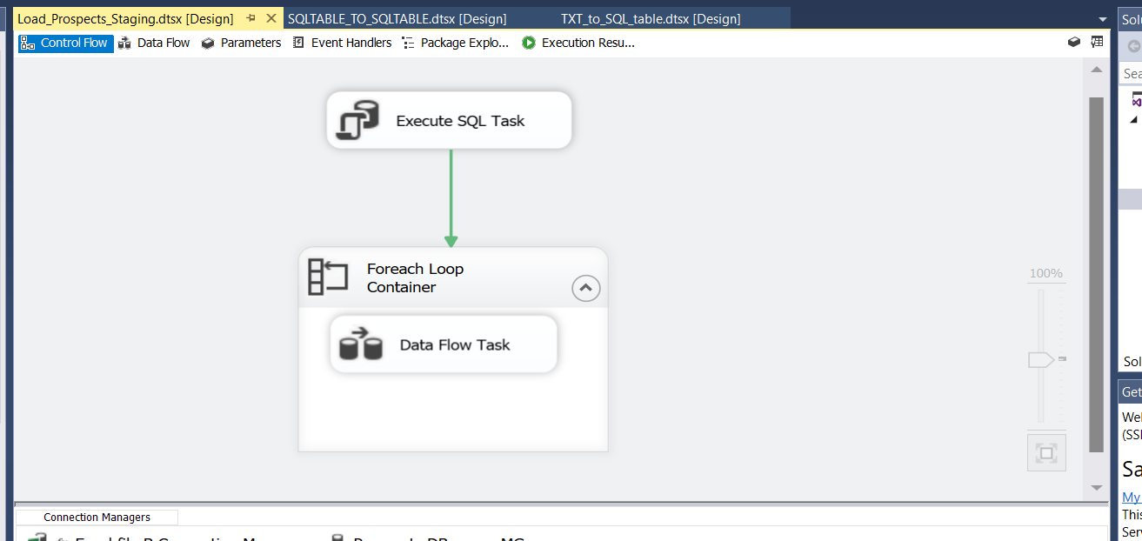

Add ForEach Loop container for getting all files in folder one by one

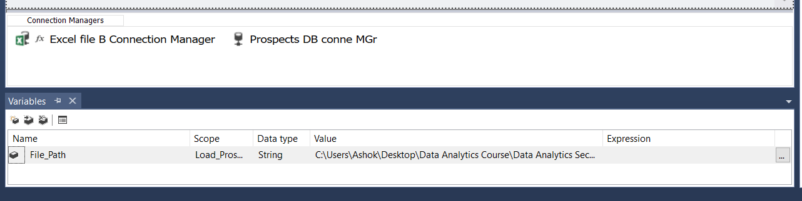

Adding variable for Excel files location which has data type as String.

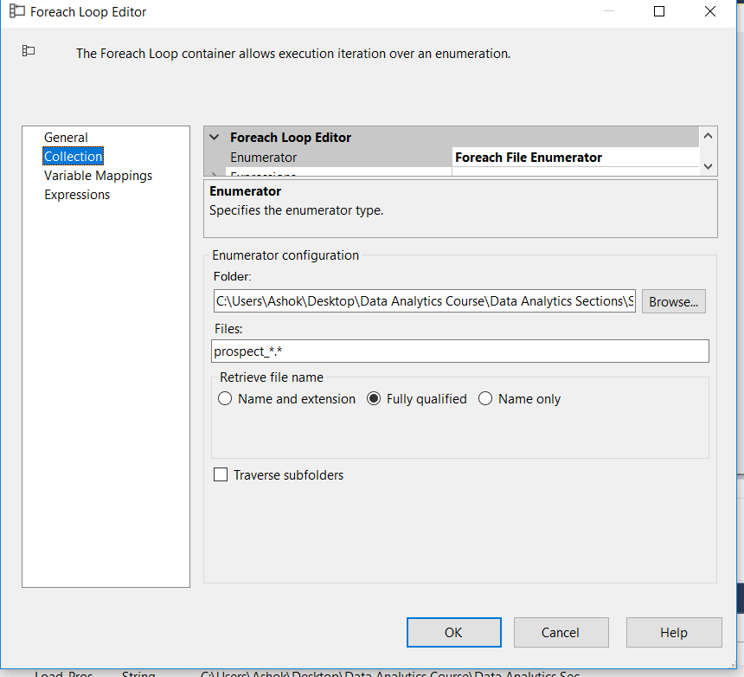

Need to change For Each Loop editor as

Collection part Enumerator as For each File Enumerator, Folder path to Excel file and Files wildcard name for fetching files.

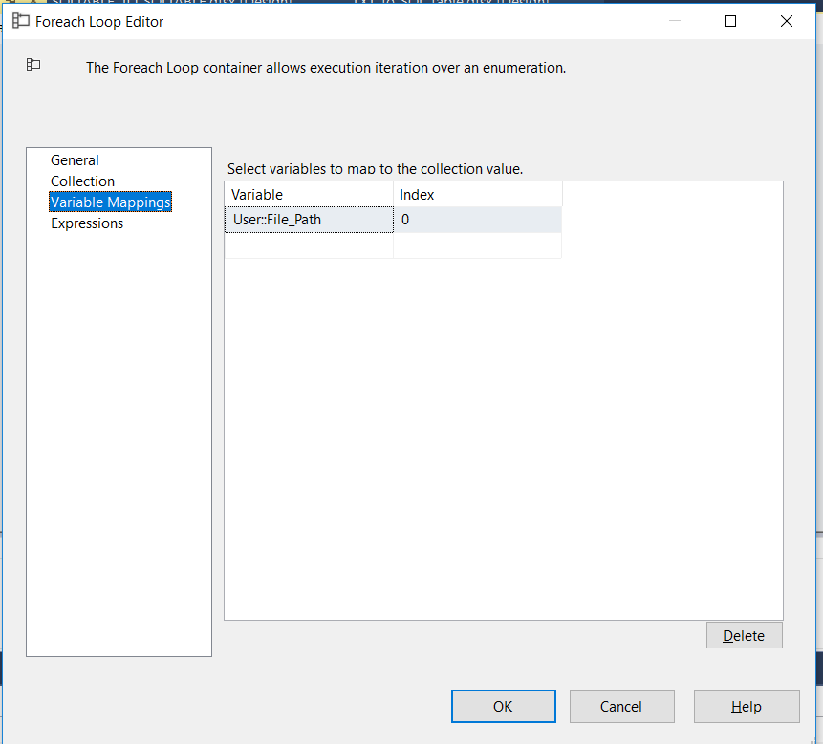

In variable Mappings part we have to select File location folder path variable as shown in image

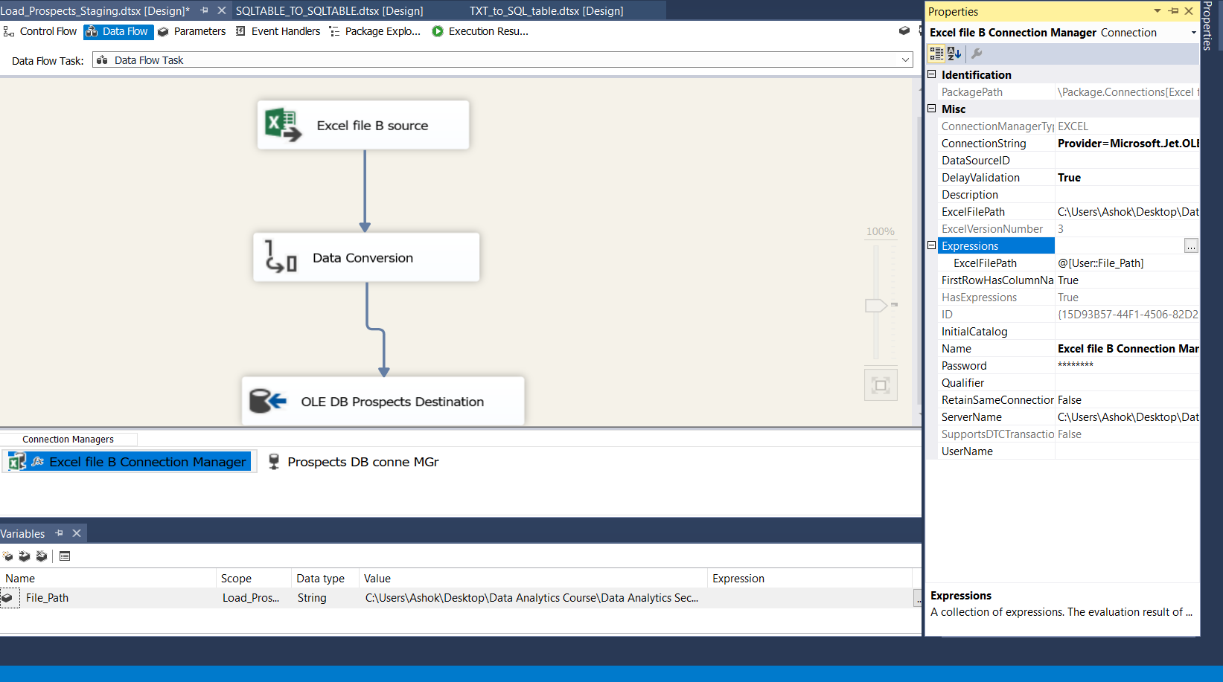

Now we have to change the Connection manager property Expression value to Variable for File location as show in above image.

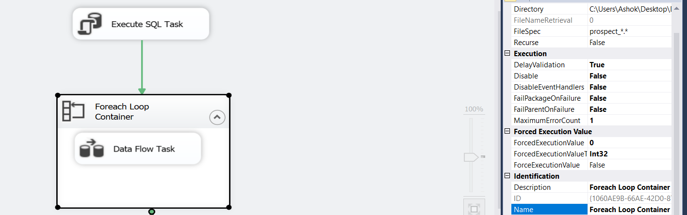

Need to set Delay Validation to True for all tasks and For Each Loop Container as we are getting file path at runtime for Excel files so validation is not needed ahead of execution.

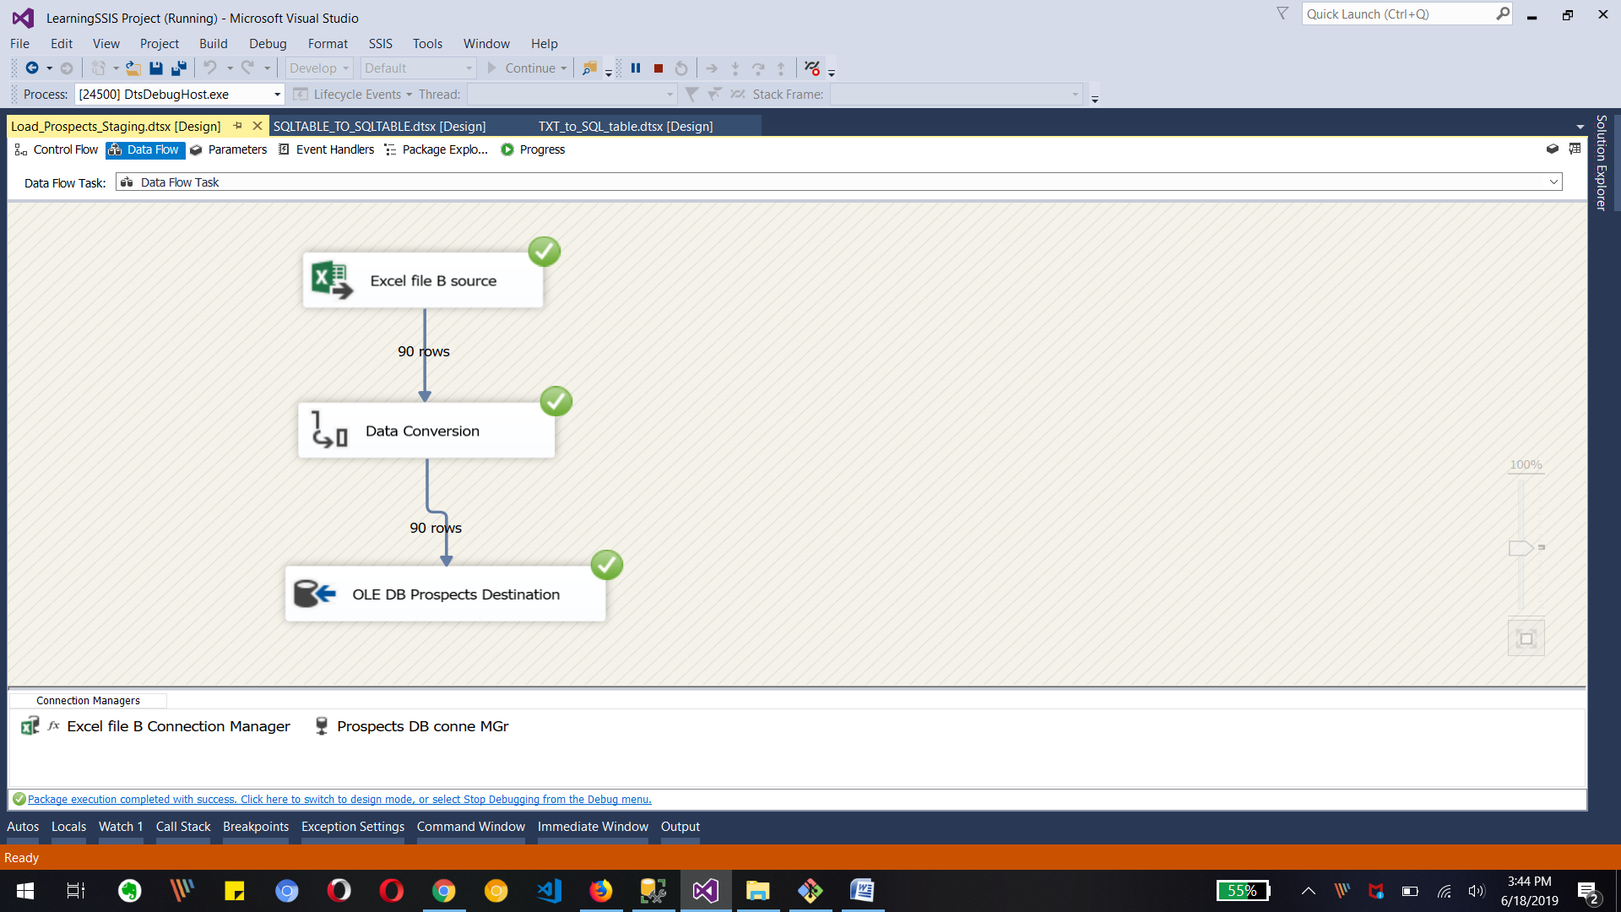

Run the package and output shows above image

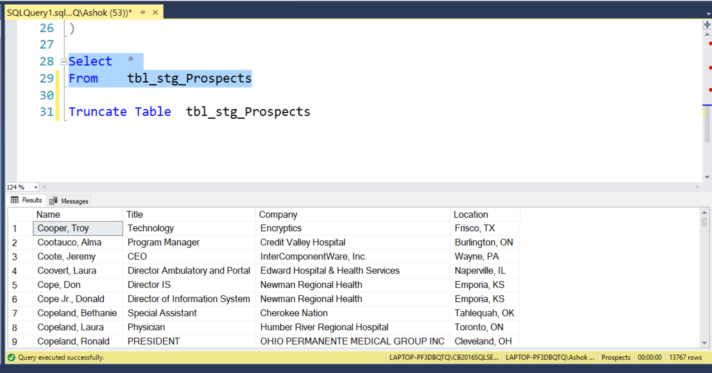

The Table in SQL server Database is also update with 13767 rows as above image.